

Induction Information
For
Junior Members

Contents List

Induction Information 1
1 Introduction 3
2 Junior Categories/Membership 3
3 Junior Officers Contact Details 2026 4
4 Communications 4
5 Junior Development Program 5
5.1 Moving Through the Junior Development Program. 6
6 Securing a Handicap 6
7 Rules for booking Tee Times on BRS 8
7.1 Junior Members - Category A 8
7.2 Junior Members - Category B 8
7.3 Junior Members – Category C 8
7.4 Juniors Playing Casual Golf 9
8 Golf Etiquette 9
8.1 Driving Range Etiquette / Rules: 9
8.2 Course Etiquette / Rules 10
8.2.1 On the 1st Tee 11
8.2.2 On the Course 11
8.2.3 THE SCORE CARD 13
8.3 Clubhouse Etiquette: 14
9 Dress Code 14
10 Integrity in Junior Golf 14
10.1 Safeguard You: 14
10.2 Protect the Field 15
10.3 Golf is Different 15
10.4 Honesty in scoring 15
10.5 Why it matters for Juniors 16
10.6 How coaches and parents can support it 16
11 Conclusion 16

1 Introduction
The purpose of the Junior Section of Athlone Golf Club is to develop and grow Junior Golf within the Club, to provide a framework within which our junior golfers can mix with their peers, develop their golfing skills and enjoy the game of golf.
We want to encourage our junior members to become active participants in the club including junior representation at inter club and national level. Through active participation in our Junior Program, we are very hopeful that many of our Junior Members will go on the be Full Members of our club.
This Document sets out the rules each junior is encouraged to follow and will be used for induction for all Juniors and Parents of Junior members. The Club wishes that every junior member enjoys their participation in a disciplined manner, and always demonstrate courtesy and sportsmanship, irrespective of how competitive they may be. This is the spirit of golf.
Note :
All policies included in this Induction Program are open to continuous review and update when required.

2 Junior Categories/Membership
Juniors must be 8 years of age on 1’st November of the membership year, before they can register as a member of Athlone Golf Club. Junior members move from Junior Category when they have completed their 18th year. The following categories are included:

Junior Category A – includes:

- Junior Girls with a HI of 39.9 or less

- Junior Boys with a HI of 19.9 or less

Junior Category B includes:
- Junior Girls with HI of 40 – 54
- Junior Boys with HI of 20 – 54
Junior Category C includes:
- Junior Girls and Boys who have not yet secured a Handicap
These categories are used to define playing rights including use of BRS for booking Tee Times.

3 Junior Officers Contact Details 2026
Name Title Contact Number.
Gerry Brennan Junior Convenor 087-2323307
Kevin Grealy PGA Professional 087-2148828
Marc Butler Team Coach 087-8558245
Jackie Kelly Club Children’s Officer 087-9805217
Ted O’Brien Club Liaison Officer 087-2187553

4 Communications
All communications to parents on Junior Golf activities are handled through WhatsApp Group “AGC Program Comms” using messages and polls to ascertain attendance numbers etc.
Messages and Polls can only be sent by Group Members with Administrative rights.

5 Junior Development Program

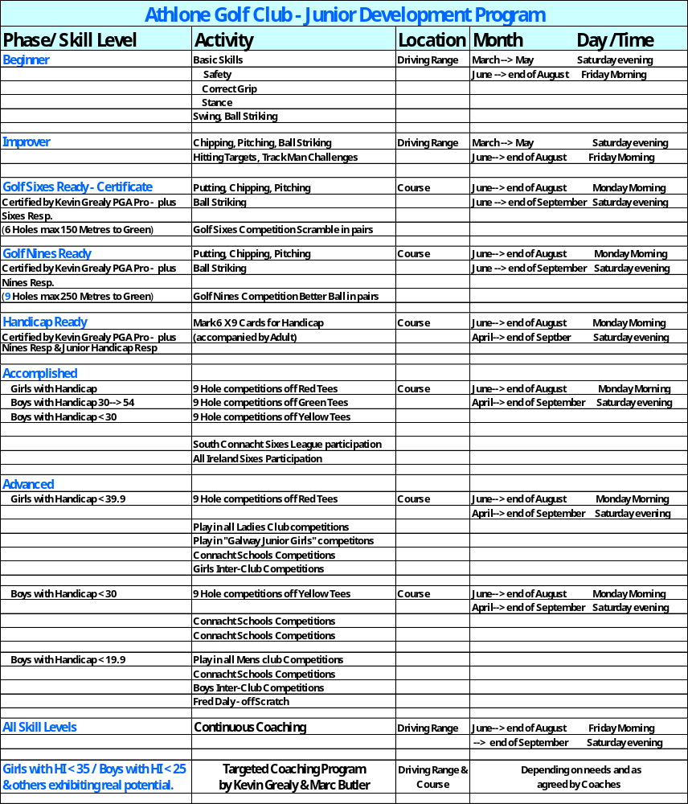

5.1 Moving Through the Junior Development Program.
- Movement from the Range to Sixes, Nines and Handicap Ready will be strictly managed By PGA Pro, Team Coach, Sixes Responsible, Nines Responsible and Junior Convenor.

- In addition to golfing ability achieved, maturity exhibited by the Juniors on the Range and on the Course will also impact the decision to move to next level or not.

- Pressure from parents to move their child to next level will not be tolerated. Juniors must have attained the required level before they can move up. Take the swimming analogy!

- All Junior Players in Athlone Golf Club must come through the Junior Program.
Any players not willing to participate in the coaching activities within the Junior Program are not welcome which means they will not continue as Junior members.
- It will not be possible to secure a handicap or any playing rights as a junior member unless the junior member actively participates in the Junior Program.

6 Securing a Handicap
To secure a handicap all Juniors must adhere to the following requirements / criteria:
- Complete 6 x 9 Hole Cards or 3 x 18 Hole Cards.

- Cards must be placed in Junior Box in the Golf Club for collection by Junior Handicap Responsible on Junior Committee.

- Card must be marked and signed by a club member with official handicap.

  - The club member can be a Junior Member with Handicap
or
  - The Junior’s Parent or Guardian who is a Club Member with official handicap

- Card must be signed by the Junior member and Marker.

- Date of play must be entered on card

- Course Played must be Ticked on card

- Competition slot on card must be marked “For Handicap”

- All details on the card must be clearly legible.

- An actual score must be entered on each of the 9 holes on the card.
  - Handicap secretaries will not accept a card with either a dash or zero as a score for the purpose of securing a handicap.

- Competition Starter of Junior competition must ensure that the Junior member who is the nominated marker of card for handicap has already secured official handicap. Otherwise, the 3 ball must be supervised by a Junor Leader or Parent.

- The score entered for 9 holes must be of high enough standard to be acceptable for handicap. This will be defined by Handicap Responsible on Junior Committee, Team Coach & Club Professional plus recommendations from Golf Ireland.

Please remember, there is no rush to secure a handicap. It’s not a rat race.
Juniors should be more focussed on becoming a good golfer so that when they get a handicap, they will be able to play off it.
Too much emphasis on securing a handicap and then getting it low, to keep up with peers, can cause other issues including breach of integrity which can become a very tricky issue for the Junior.
We organise a huge number of formal competitions during the season, which allow each junior to fulfil the requirement of securing 6 x 9 hole cards.

7 Rules for booking Tee Times on BRS

7.1 Junior Members - Category A
May book and play via BRS as per Ordinary members and play in Junior Competitions.
Girls with HI of 39.9 or less – may book and play in Ladies club competitions at any time.
Boys with HI of 19.9 or less – may book and play in men’s club competitions at any time
Exceptions : Special competitions e.g. Plumbers, Club ’97, Wednesday Golfers

7.2 Junior Members - Category B
Girls with HI of 40 or more are not permitted to play in Ladies club competitions.
Boys with HI of 20 or more are not permitted to play in men’s club competitions.
Girls with HI of 45 or more and Boys with HI of 40 or more cannot book slots using BRS. Juniors with those handicaps must book slots through the Pro Shop.
Juniors are not allowed book Guests on BRS. To do so, they should go to the Pro-Shop and book the guest in there.

7.3 Junior Members – Category C
Junior Girls & Boys who have achieved “Handicap Ready” status, can play during Junior Club competitions organised within the Junior Program on Saturday evenings and Monday mornings for the purpose of having cards marked to secure official handicap.
Category C members cannot use BRS to book Tee Time slots on the course.
Category C members can play on the course outside Junior Slots supervised by their parents or guardian.

7.4 Juniors Playing Casual Golf
We would like to remind parents/guardians that the Club does not provide supervision outside Junior competitions and organised group activities.
The Club cannot provide any guardianship during unsupervised playing of casual golf.
We recommend that Juniors do not play alone & Juniors should not be dropped off or left unaccompanied at the Golf Club under the age of 12.
Parents/Guardians are encouraged to accompany their child (need not be in a golfing capacity) while he/she plays casual golf, particularly while they are beginners. Parents are requested to familiarise themselves with course etiquette and course safety and ensure their child practices the same.

8 Golf Etiquette
Understanding and practicing good golf etiquette is an absolute requirement for all golfers.
Golf etiquette starts the first day you join the Junior Program in Athlone Golf Club. The list below (not an exhaustive list) are the basic practices required to ensure golf is enjoyable and safe for you and all fellow golfers:

8.1 Driving Range Etiquette / Rules:
- Please be on time for your allotted time

- Be careful not to disturb golfers using driving bays allotted for public use.

- Please check in with Leader taking attendance records.

- Place you bag at back of golfing bay.

- Do not hit golf shots until session has been formally started by PGA Pro or Leaders running the session

- Always ensure that there is a safe distance between you and other players when swinging your golf club

- Remain quiet when your fellow golfers are hitting their shots.

- All golf shots must be directed at targets within the Driving Range. It is totally unacceptable to direct shots towards Out of Bounds.

- This can result in golf balls being lost which has a business impact to the Range owner.

- Even more serious, locals living beside the range or those travelling on the road to the right of the range can be injured by low flying golf balls.

- Respect the Trackman equipment on the range which is extremely expensive.

- Be careful not to strike any of the screens when swinging your club.

- Respect the coaches on the range by paying attention to the coaching drills.

- Leave the range by side gate when session is completed, for collection by your parent/guardian in the car park

8.2 Course Etiquette / Rules
You must have the following items when playing on the course:
- Your own Golf Bag and clubs. Max number of clubs permitted in your bag is 14

- Golf Shoes

- Proper clothing including rain gear.

- An Umbrella

- A sufficient number of golf balls

- Pitch Mark Repairer – to repair pitch marks on the green

- Ball Marker – to mark your ball on the green

- Sharpie – to mark your ball with personal identification mark

- Tees
  - Long Tees to use with your driver
  - Short Tees to use with 3 Wood and Irons

- Pencil or biro

- Water

- Some snack can be important if you are playing 18 holes.

8.2.1 On the 1st Tee

- Please be on time for your allotted tee time

- Swap cards with your playing partners

- Make sure to place an identifying mark on your ball and inform your playing partners the type you are playing.

- Remain quiet when your fellow golfers are hitting their shots.

- Never take a shot if another player is directly in front of you and in danger of being struck by your golf ball.

- Always ensure that there is a safe distance between you and other players when swinging your golf club.

- If you believe there is a risk that your ball may be lost, Always play a provisional ball. This will save time!

- Place an identifying mark on your provisional ball and inform your playing partners the type you are playing.

8.2.2 On the Course

- At all times, the rules of golf must be observed. Be courteous to those playing with you and elsewhere on the course. Never run or shout. Do not litter the course. Pick up litter you see and take pride in the course.

- Maintain a good pace while playing your round.

- Your place on the course is just behind the group in front of you rather than just ahead of the group behind you.

- If you are not ready to hit your shot, encourage your fellow players to hit their shot if safe to do so.

- If you lose a ball, while you can take the 3 minutes to look for it according to the rules of golf, you should allow those behind you to go through.

- To make it easier to find a ball, always watch your playing partner when they are taking a shot.

- If you lose one complete hole, please allow players behind you to go through.

- If your ball or your playing partners ball is at risk of hitting another golfer on the course, you must shout “fore” loudly.

- Please do not bring you caddy car onto the greens or tee boxes.

- Please position your caddy care on the exit side of the green which will enable you to move swiftly to the next hole.

- Do not knowingly stand on the line of another player’s putt. Replace the flagstick carefully in the hole to avoid damage to the side of the cup.
Never use the putter head to remove your ball from the hole. This can damage the hole.
- Do not cut in on a hole on the course.

- Players must ensure they do not damage the course in any way.

- Please repair divots on the course and pitch marks on the Greens. Use pitch-mark repairer. Make yourself aware of correct procedure when repairing pitch marks. Correctly repaired pitch recovers within 1 day. Damage from a badly repaired pitch-mark will last minimum 1 week.

- Repair tee box divots with the seeded sand provided and rake bunkers.

- Please use bins, observe signs and use air-bay when exiting course.

- The use of mobile phones is not permitted on the course or in most areas of the Clubhouse. You may use a mobile phone in certain designated areas of the Clubhouse and outside the Clubhouse having regard at all times to speaking quietly, especially when close to areas of the course.

- You can carry a switched off mobile phone on the course for emergency use in the case of an accident. Be sure to have the Clubhouse and Pro Shop numbers in your phone memory for such emergencies.

8.2.3 THE SCORE CARD

- Exchange scorecards with your playing partner(s) prior to commencing play.

- Fill in the scorecard at the next tee rather than on the green.

- Always fill in your own score in the Markers section on players card you are marking.

- Check and sign your scorecard immediately after your game, before you enter the clubhouse. Cross-check your own score which you have captured on players card you are marking with the score entered by your marker.
If there are any discrepancy, please confirm the correct score with your marker. Discuss with other players in your group if required.
Only Sign your card when you are sure the score is correct.

The key data, which must be included on your scorecard, is as follows:

Competition Details: Course Played: Date:
Your Name: Your Handicap:
Your score at each hole:
Your signature Markers signature
When marking another player’s card, always write your own score in the “Marker’s Section” on the card. This score should be cross-checked at the end of the round with your own score which has been marked by your playing partner.
Remember, the Score you sign for is the Valid Score. Ensure its correct before you sign the card. If you sign for an incorrect score, you will be disqualified if picked up by competition organiser.

8.3 Clubhouse Etiquette:
- Junior club members are permitted to be in the Restaurant and may partake of food and non-alcoholic drinks.

- They are prohibited to purchase or the attempted purchase of alcoholic beverages.

- Please be respectful of all members when using these facilities.

- Please adhere to the junior dress code when in the restaurant area.

- Please do not wear golf shoes into the restaurant or bar area. Take off golf shoes and leave them outside door where they are not blocking the entrance.

9 Dress Code

Athlone Golf Club takes a relaxed attitude to Dress Code for Junior Golfers as per Golf Ireland policy. Neat, Tidy and weather appropriate is the baseline.

10 Integrity in Junior Golf
Integrity in junior golf is one of the sport’s most important values
Golf is a “game of Honour,”
Cheating is totally unacceptable for a Junior golfer or any golfer. You commit to” NO Cheating” when you sign your “Junior Code of Conduct” when you join the club.
A Zero tolerance policy will be implemented by our Junior Program.
This is required to Safeguard you as a Junior and Protect “The Field”.

10.1 Safeguard You:
As a Junior Golfer, Cheating is a very serious issue which you should never contemplate.
It can destroy your friendships, your character and your future in golf. If you cheat, you will find it difficult to get playing partners, not just as a junior but also as an adult.
If you have cheated in the past, please stop it now and ensure by your actions that you build back your reputation with your peers and Junior Committee who run the Junior Program.
Cheating will totally block your possibility to represent the club at inter-Club, Provincial or National level.

10.2 Protect the Field
The Field means all competitors in a competition.
The player who brings in the best score, which is legitimate, should always win the competition.
If by cheating, you win a competition, you are taking a prize which should have gone to another player who may be your friend.
As a marker of another player’s card, you have a big responsibility to ensure the score on that player’s card is correct before signing as a marker.
That is also protecting the field

10.3 Golf is Different
Golf is different to almost all other sports.
In other sports, there are referees who ensure the rules are policed.
In Golf, most of the time there are no referees. Of course, In big competitions, referees can be called in for specific ruling.
You are your own referee
At its core, integrity means doing the right thing even when no one is watching.

10.4 Honesty in scoring
- Young players are expected to keep their own scores and report them accurately. If a player accidentally takes an extra stroke or incurs a penalty, integrity means counting it, even if it hurts their score.

- You must count correctly. On completion of a hole, you must call out the actual score you had to your playing partners. This includes penalty for lost ball, missed shots out of bunker, missed 6-inch putt. Every shot must be counted.

- Playing partner who is marking your card must be aware of the no. of shots you have taken. If the marker or other playing partners are not satisfied with the score called out, they must immediately clarify the situation before the score is marked on the card, and before moving to next hole.

10.5 Why it matters for Juniors
Learning integrity through golf goes beyond sport. It helps young players develop:
- Strong character and accountability

- Trustworthiness in competitive situations

- Emotional maturity and resilience

- These habits often carry into school, work, and everyday life.

10.6 How coaches and parents can support it
- Emphasize effort and honesty over winning

- Praise players for making the right call, even when it costs them

- Model respectful behaviour on and off the course

11 Conclusion

Remember :
In junior golf, talent might win tournaments,
but integrity is what
builds lasting respect and a true love for the game.

